SAlex

Inside this issue:

President’s Message 1

Basket Auction 1

Programs 2

Book Clubs 3

State Convention 3

Board Updates 4

***Branch Bits and Pieces*** is published two times a year (August and January)

Editor: Mary Kahler

**AAUW’s mission statement: Advancing equity for women and girls through advocacy, education and research**.

Special points

of interest:

* Board Notes
* Program information
* Fundraiser Update
* State Convention
* Book Club titles



**Happy New Year!**

My wishes for all of you in 2021 are patience, hope, resiliency, good health, unity, and happiness.  Any other year this greeting would sound cliché, but I think we can all agree that this year it has true meaning!

As we forge ahead, we want to remain safe so most of our spring programs and book clubs will continue via Zoom.

I am especially looking forward to our modified end-of-the-year “brunch” where I am hoping I will be able to see all of you in person.  See the newsletter for details on all the fun programs and activities.

The newsletter has information on the virtual State Convention.  The committee has worked hard on this year’s event, so I hope you will plan to tune in to all or part of it.

Also, THANK YOU so much for your generosity is keeping our scholarship money intact for 2021!  You are awesome!

Again, because I can’t say it enough, Happy New Year!

Diane



***BRIGHTER FUTURES***

Last summer our Executive Board, because of COVID, cancelled the October basket auction and decided to try a direct appeal to our members to raise the money we need to give out scholarships in the spring. The Board set our fundraising goal at $5,000, in order to fund two high school and one MPTC scholarships. A GoFundMe page was created under the title “Brighter Futures”, and members were asked to contribute. Our generous members and their friends responded with enough funds to surpass our goal by over $800.  When one magnanimous member saw how close we were to hitting our last year’s total, they responded with an additional check to give us a final figure of $6,000.  This enables us to give out two high school and two MPTC scholarships this spring. In total, seven nonmembers and 98% of our members contributed to this effort.  Thank you to everyone who helped make this such a bright light amidst the COVID gloom.

--Bobbi Marck

Committee Chair

*.*

---------------------------------

**A TISKET, A TASKET, WHERE’S THE BASKET**

Due to covid restrictions, the board unanimously voted to cancel our annual Basket Auction in October. In its place will be a simple fundraising campaign. The goal is to raise enough money to cover the scholarships that we support. Look forward to more information at our September meeting. Members of the fundraising committee are Bobbi Marck, Deanna Disch, Carmen Hanson, Diane Kitchen, Nancy Palm and Andrea Utrie.

## Dear AAUW Members

# AAUW-WI Beaver Dam

January 2021

BRANCH BITS AND PIECES

Kathleen Waldvogel, author of “Spies, Soldiers, Couriers and Saboteurs: Women of the American Revolution”, will talk about her book, her work as an author and other projects she may have in the wings on March 24 at 6:30. She will be doing this over Zoom. Stay tuned for the link.

We are hoping that we will be able to meet in person for our April 21 meeting. This will involve a “Walking Tour of Downtown Beaver Dam”. We hope to start at the Chamber of Commerce, 127 South Spring Street, at 6:30. Since the majority of this program will be outside, we are hoping it will work. The average daily temperature for April 21 is 60 degrees (I looked it up). Stay tuned to your email.

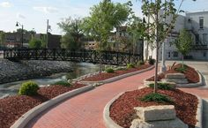

The May “End of the Year Brunch” has been cancelled and replaced with an “End of the Year Lunch”. Members will be encouraged to bring their own bag lunch to Swan City Park around 11 on June 12. We will be meeting at the shelter that is closest to Mill Street. And we even have entertainment lined up. Madame Rose and Professor Lazlo will perform “The Deluxe Magic Show”. If you think that Madame Rose looks familiar, you might be right. Archan Sramek is Madame Rose.

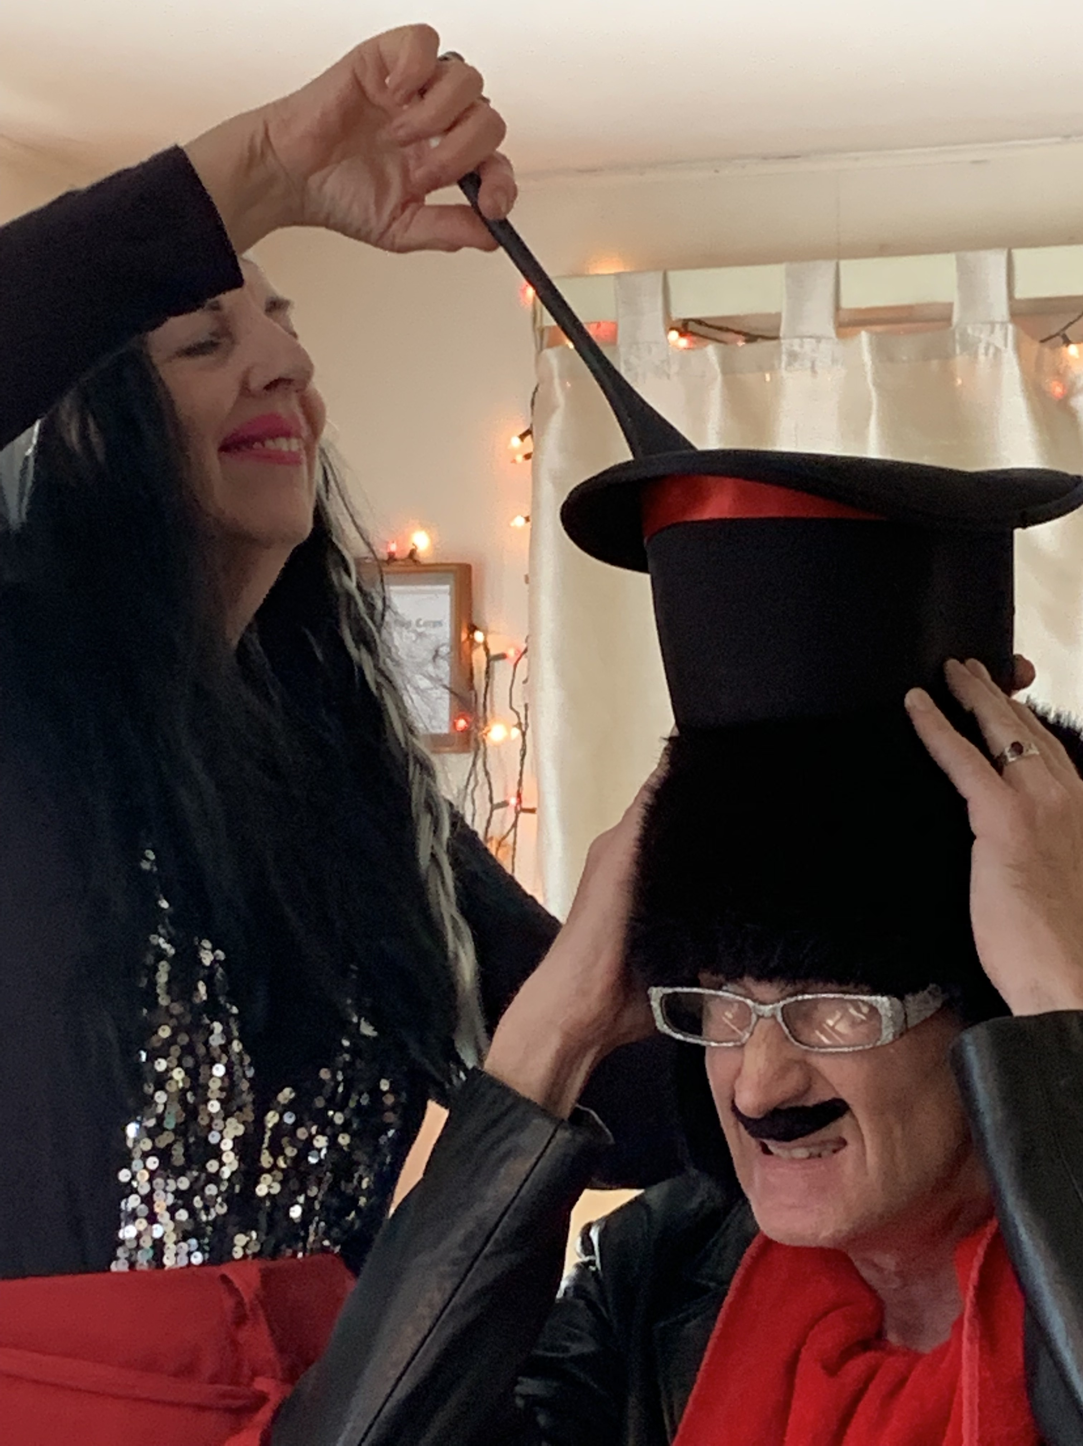At the 81st annual convention of the Houdini Club in 2019, they placed first in the Stage Magic Contest. They also won an award for Design and Costuming Award. Hoping that no one gets sawn in half on June 12.

The Board has been frantically trying to rearrange and relocate our programs this year due to the ongoing restrictions of COVID. If changes occur, you will get either a phone call or an email.

January will get you buzzing as we bring in a beekeeper. Scott Hankes has taken up the hobby of beekeeping and he will inform us all about beekeeping. Join us on January 20 and bee there at 6:30. This program will be available through Zoom.

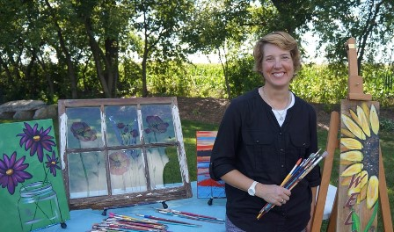

Kris Schumacher will talk about her business Art On The Town WI—The Studio. This new business features make-it-yourself projects. The program will begin at 6:30 on February 17. We are hoping to provide some opportunity for members to socialize with some ice-breaking activities as well. Look for the Zoom link.

**Calendar:**

1-12 Day Book Club

1-20 AAUW Program

1-25 Night Book Club

2-9 Day Book Club

2-17 AAUW Program

2-22 Night Book Club

3-9 Day Book Club

3-22 Night Book Club

3-24 AAUW Program

4-13 Day Book Club

4-21 AAUW Program

4-23 to 24 AAUW-WI State Convention

4-26 Night Book Club

5-11 Day Book Club

5-24 Night Book Club

6-12 End of Year Lunch

## PROGRAMS TO START THE YEAR

page 2

BRANCH BITS AND PIECES

AAUW-WI

April 23-24

Virtual Convention

Due to COVID, our state convention will be presented virtually this year. This is the time to participate in it…no registration fees, no travel, no lodging.

Currently, the plans are for a start on Friday, April 23 from 7 to 9—featuring opening remarks and a conversation between two suffragist re-enactors.

Then continuing on Saturday, April 24 with a business meeting from 9:30 to 10:45; a featured speaker, Rep. Shelia Stubbs from 11 to 12; two breakout sessions from 12:10 to 2:00 and finishing with Jessica Michna’s presentation, “Women Who Dared” from 2-3.

A virtual auction will also be going on during the event.

All the information plus updates will be on a website dedicated to the convention. In addition: emails and Badger Briefs will provide even more details.

Book clubs, both morning and afternoon, continue full speed ahead despite the pandemic. If you are a regular member of a particular book club, you should receive an invite for a Zoom meeting for that date. If you would like to join in and have not received an invite, contact the hostess for an invite. If you are unfamiliar with Zoom and would like to participate, contact the hostess. Enjoy!!

**MORNING BOOK SELECTIONS**

The new year begins on January 12, with The Girl in the Photograph by Byron Dorgan. Some people have considered this one of the most important civil rights books of the century as it examines the plight of Native Americans on reservations. Bryon Dorgan, the author, is an ex-senator of North Dakota. The hostess is Christa Slinger.

Jeanine Cummins is the author of American Dirt, the book of discussion for February 9. It is a novel of a Mexican mother and her son who attempt to immigrate to the United States. Annette Kamps is the hostess.

Kathleen Ernst has not only written many books but she has a Wisconsin edge. She has worked at Old World Wisconsin and many of her books are about Wisconsin. The featured book for March 9 is Old World Murder but participants may talk about other books that she has written. Deanna Disch is the hostess.

April 13’s book of discussion is Looking for Alaska by John Green. This book is a coming-of-age novel that touches on themes of grief, hope, and youth-adult relationships. The hostess is Diana Schneider.

The Professor and the Madman by Simon Winchester is the book for May 11. Despite the title, it is about the making of the Oxford English Dictionary…oh, but it would be that boring…murder and insanity are involved as well. Kay Stellpflug is the hostess.

**EVENING BOOK SELECTIONS**

A Fire Sparkling by Julianne MacLean is the focus of discussion on January 25. It is a novel of one woman’s love, loss and courage during World War II. The hostess is Mary Kahler.

A psychological thriller is in store for the February 22 book club selection. The Silent Patient by Alex Michaelides has been in the top ten books most of this past year. This page turner should be a good discussion. Jan Sutter is the hostess.

Melanie Benjamin’s The Aviator’s Wife is the book for March 22. Most of us are familiar with Charles Lindbergh, but do we know about his wife, Anne Morrow? This book focuses on Anne. Denise Roedl is the hostess.

Whiskey When We’re Dry by John Larison is the focus of discussion on April 26. The main character of this novel is not one that you will soon forget. The setting is the Wild West—and all that goes with. The hostess is Cindy Noe. And she promises that if it is at her house, you will probably know what the beverage will be.

The Shape of Family by Shilpi Somaya Gowda is a novel for our times. It is about race and culture, parents and siblings, marriage and love. A robust discussion of all of these will be in store on May 24. Kathy McMichael will be the hostess.

## BOOK CLUBS PERSIST

BRANCH BITS AND PIECES

page 3

The board met on December 9 via Zoom. Some of the highlights:

The Basket Auction was cancelled due to the uncertainty of being able to meet. In its place we held an online fundraiser spearheaded by Bobbi Marck. This brought in $6,004.85; enough to cover two high school scholarships at $2,000 apiece and two Moraine Park Technical College scholarships at $1,000 each. There was some discussion about perhaps offering more MPTC scholarships, but the board decided to remain with the current designations.

Leiken Stollenwerk and Angela Matzen, students at Moraine Park Technical Colllege received $1,000 scholarships from us.

The AAUW State Spring Convention will be held virtually April 23-24.

The board approved of giving $50 stipends to our program speakers for the 2020-2021 year. Speakers may either donate it to the cause they represent or accept it for the time given.

We have three open positions:

* Treasurer
* Vice-President
* Corresponding Secretary

If interested, please contact Diane Kitchen.

As of 12-9-20, we have $6,759.02 in checking and $2,302.99 in savings

**AAUW**

**American Association for University Women**

**Beaver Dam Branch**

**Check us out on our web page:**

**beaverdam-wi.aauw.net**

## BOARD NOTES

mary kahler

209 Beaver Street

beaver dam, wi 53916

recipient name

street address

address 2

city, ST ZIP code

**BRANCH BITS AND PIECES**

page 4